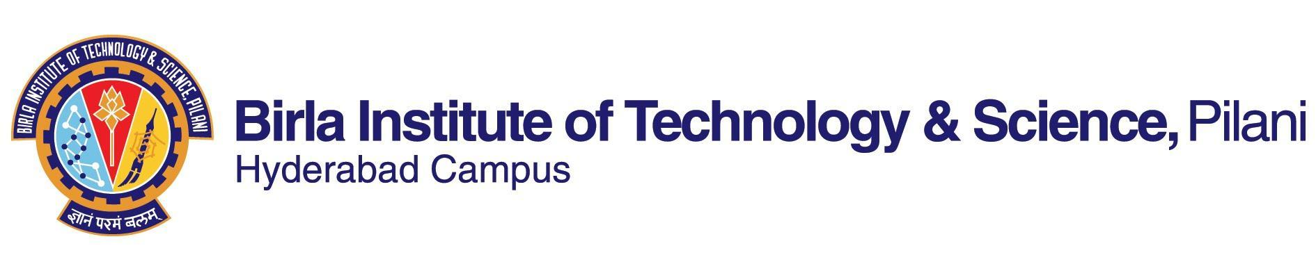

**FIRST SEMESTER 2022-2023**

Course Handout Part II

Date: 29-08-2022

In addition to Part-I (General Handout for all courses appended to the timetable), this portion gives further specific details regarding the course.

*Course No.*  : BITS F437

*Course Title* : Technical Communication

*Instructor-in-Charge*:Prof T. Vijay Kumar

**Scope and Objective:**

This course aims to make students of Higher Degree understand and effectively use English for academic and professional purposes. While students will be made aware of theoretical aspects, greater emphasis will be laid on practical application. Students will be exposed to different types of authentic textual materials to broaden their awareness of and enhance their ability to use English in academic and professional contexts. Going beyond teaching basic language skills, the course seeks to help students acquire higher-order thinking skills.

**Text Book:**

1. Edward De Chazal and Julie Moore​. 2013​​. *Oxford EAP: Advanced/C1: Student's Book and DVD-ROM Pack​*. Oxford University Press.

**Reference Books:**

1. Martin Hewings and Craig Thaine. 2014. *Cambridge Academic English (Advanced) Student’s Book*. First South Asian Edition. Cambridge University Press.
2. Adrian Wallwork. 2015. *English for Academic Research: Writing Exercises*. Corr. 2nd printing 2015 edition. Springer.
3. Peter Levrai and Averil Bolster. 2015. *Academic Presenting and Presentations: Student’s Book*. BoD – Books on Demand.
4. Tamzen Armer. 2011. *Cambridge English for Scientists Student's Book with Audio CDs (2).* Cambridge University Press.
5. Stephen Bailey. 2018. *Academic Writing: A Handbook for International Students*, 5th Edition, Special Indian Edition, Routledge.

Note: Text and reference books listed above will be supplemented, if and when needed, with other resources in the classroom. Students are expected to be familiar with the additional reading material as well.

**Course Plan:**

|  |  |  |  |
| --- | --- | --- | --- |
| **Lecture No.** | **Learning objectives** | **Topics to be covered** | **Chapter in the Text Book** |
| 1-4 | Understand the course content, materials, and evaluation; Identify aspects of technical communication and English for academic and professional purposes | Introduction to the course; Types of communication; Definition and features of technical communication; Academic and professional English language skills | TB, Ch1; Web sources |
| 5-15 | Use elements of effective writing | Elements of effective writing:  • Presenting arguments  • Cause and effect  • Comparison  • Problems and solutions  • Process writing  • Visual information  • Caution  • Linkers/Signposting  • Summarizing and paraphrasing | TB, Ch2, 4, 8 & 10; RB5., pp. 50-61; RB1; web sources |
| 16-26 | Identify and analyze aspects of technical proposals and reports | Technical Proposals; Technical Reports: Obtaining, organizing, and presenting information | TB; RB1, Ch. 5-10; TB; RB4; web sources |
| 27-32 | Understand the norms of academic writing and evaluate research papers/ dissertations against them | Structure and components of research papers/dissertation; Ethics in research; Documentation formats | RB2, Ch. 10; web sources |
| 33-35 | Prepare professional CV | Types of CVs; Preparing CVs | RB4; web sources |
| 36-38 | Make effective academic presentations | Effective Presentation Strategies | TB; RB3.; web sources |
| 39-40 | Participate in group discussions, meetings, and conferences | Group discussion | TB; RB4; web sources |

**Evaluation Scheme:**

|  |  |  |  |  |
| --- | --- | --- | --- | --- |
| **Component** | **Duration** | **Weightage (%)** | **Date & Time** | **Nature of Component** |
| Mid-semester Test | 30 | 90 minutes | 31/10/2022  9.00 - 10.30 AM | Closed Book |
| Assignments | 20+20 | TBA | TBA | Open Book |
| Comprehensive Examination | 30 | 180 minutes | 17/12/2022 FN | Closed Book |

**Chamber Consultation Hour:** In K-128; Thursday—9:30-10:30.

**Notices:** If any, will be posted on CMS.

**Make-up Policy:** Assignments will not berepeated.Make-up for other assessment components will be allowed only in genuine cases and on the basis of verifiable, documentary proof.

**Academic Honesty and Integrity Policy:** Academic honesty and integrity are to be maintained by all the students throughout the semester and no type of academic dishonesty is acceptable.

T Vijay Kumar

**INSTRUCTOR-IN-CHARGE**